**Batch: C3 Roll No.: 16010123217**

**Experiment / assignment / tutorial No. 9**

**Grade: AA / AB / BB / BC / CC / CD /DD**

**Signature of the Staff In-charge with date**

|  |
| --- |
| **Title:**  Implement a dictionary for some real world application. Use C/C++ or python. |

**Objective:** To implement a dictionary for real world application using python.

**Expected Outcome of Experiment:**

|  |  |
| --- | --- |
| **CO** | **Outcome** |
| 3 | Describe concepts of advanced data structures like set, map & dictionary. |

**Books/ Journals/ Websites referred:**

1. *Fundamentals Of Data Structures In C –* Ellis Horowitz, Satraj Sahni, Susan Anderson-Fred
2. *An Introduction to data structures with applications –* Jean Paul Tremblay,

Paul G. Sorenson

1. *Data Structures A Pseudo Approach with C –* Richard F. Gilberg & Behrouz A. Forouzan
2. <https://www.geeksforgeeks.org/binary-tree-data-structure/>
3. <https://www.thecrazyprogrammer.com/2015/03/c-program-for-binary-search-tree-insertion.html>

**Abstract:** *(Define dictionary as data structures,applications of dictionary)*

A dictionary, or hash map, is a data structure that stores data in key-value pairs, allowing quick data retrieval based on unique keys. It enables efficient lookups, insertions, and deletions, generally in constant time (O(1)).

**Applications:**

* **Databases**: Fast data retrieval using unique identifiers.
* **Counting**: Tracking occurrences, e.g., word frequency.
* **Graph Algorithms**: Representing adjacency lists.

**Program:**

*(Function/method name, describe its purpose and write code for the same, followed by its output)*

*Creating a dictionary:*

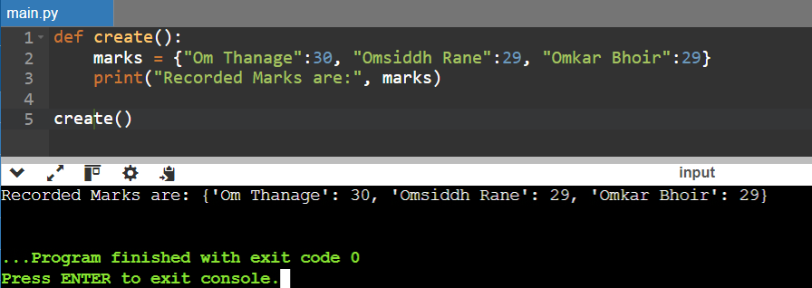

*Adding to dictionary:*

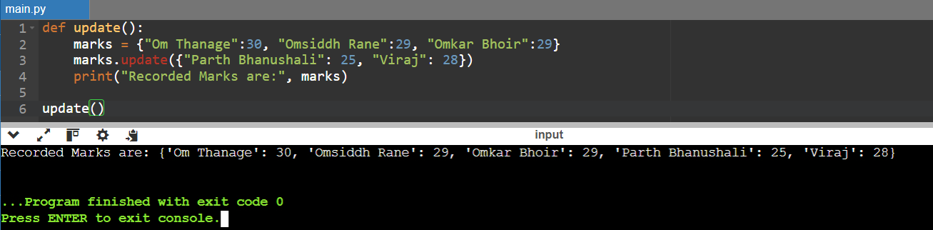

*Fetching marks*

*Getting keys of a dictionary*

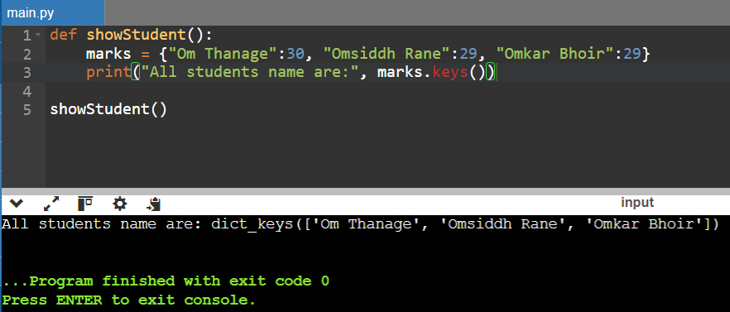

*Checking if key exists in dictionary*

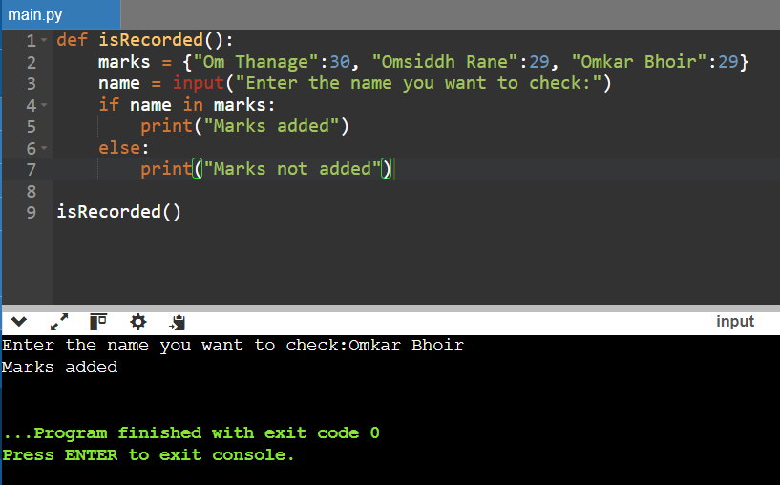

*Updating key value pairs*

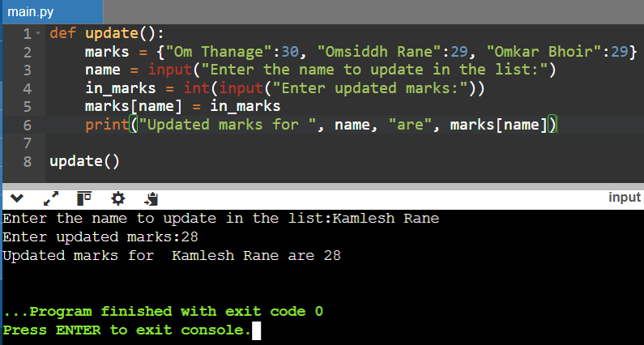

*Deleting key value pairs*

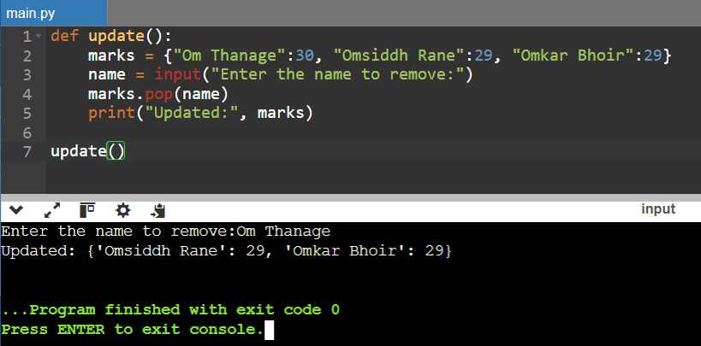

*Clearing an entire dictionary*

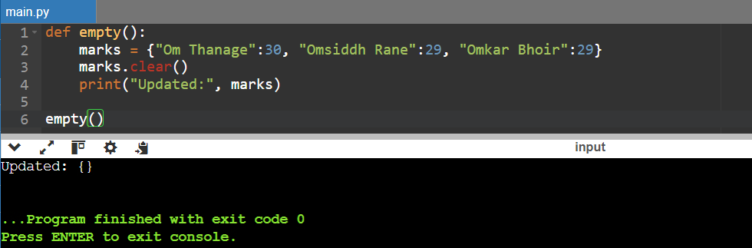

**Conclusion:-**

**In this experiment, we learnt about various functions of dictionary and it’s usage.**

**PostLab Questions:**

1. **List applications of set, map and dictionary data structures**

**Ans.**

### Set

1. **Unique Email List**
2. **User Visit Tracker**
3. **Common Interests Finder**

### Map

1. **Product Catalog**
2. **Cache for API Responses**
3. **Country-Capital Pairing**

### Dictionary

1. **Word Frequency Counter**
2. **Configuration Settings Storage**
3. **Employee Directory**